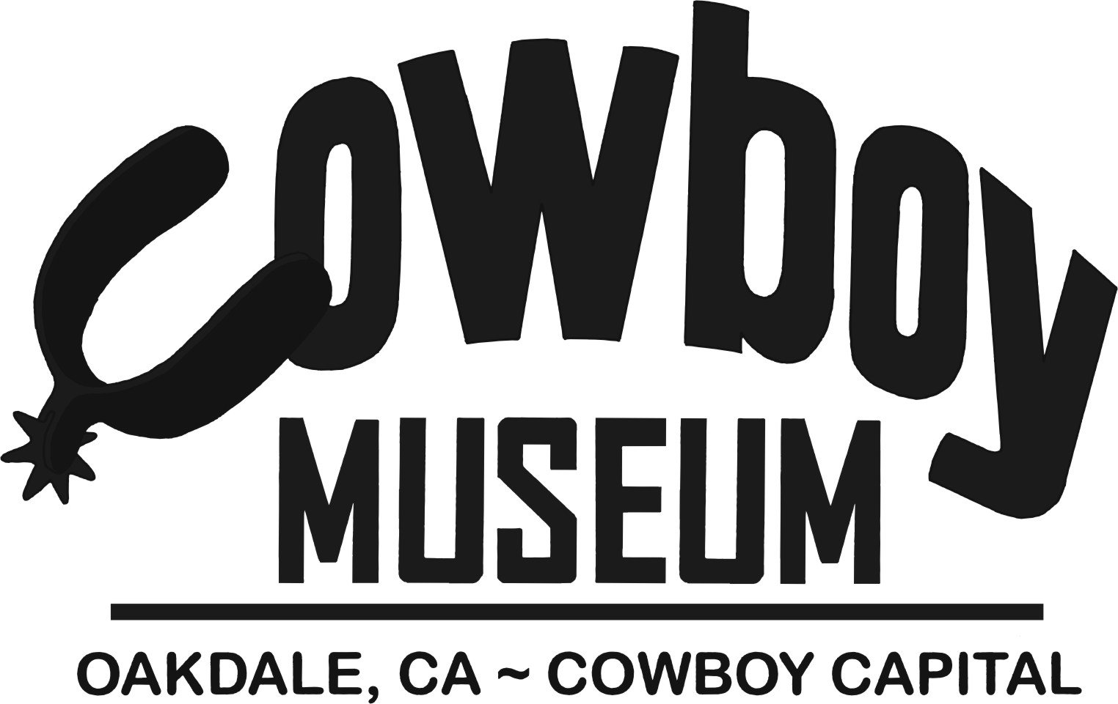

2015 NOMINATION FORM

Dinner/Auction Honoree

The Oakdale Cowboy Museum promotes and preserves the western heritage of the Central Valley by honoring our ranching and rodeo traditions. Every year at our Annual Dinner & Auction fundraiser held in September, we recognize an individual or family in two categories; living and deceased, who has been a vital part of our western history. These individuals or families have demonstrated through their daily lives the passion to continue our rich western heritage. All nominees are reviewed and voted upon by the Cowboy Museum’s Board of Directors. Nominations are due by February 28, 2015.

Nominee Information: Please indicate if they are living or deceased. (If deceased, please note family contact below.)

Name of Nominee______________________________________________________________

Address __________________________________________________________________

Phone ____________________Cell Phone_________________________

Please give a description of the nominee and their contribution to our local western history. You may use an additional page if necessary.
______________________________________________________________________________________________________________________________________________________________________________________________________________________________________________________________________________________________________________________________________________________________________________________________________________________________________________________________________________________________________________________________________________________

Nominated by: _______________________Phone_____________________________

Address: _________________________________________________________________________________

Please return to Oakdale Cowboy Museum 355 East “F” Street, Oakdale, CA 95361 by February 28, 2015. If you have any questions, please call Christie at (209) 847-5163 or email Christie@oakdalecowboymuseum.org.

