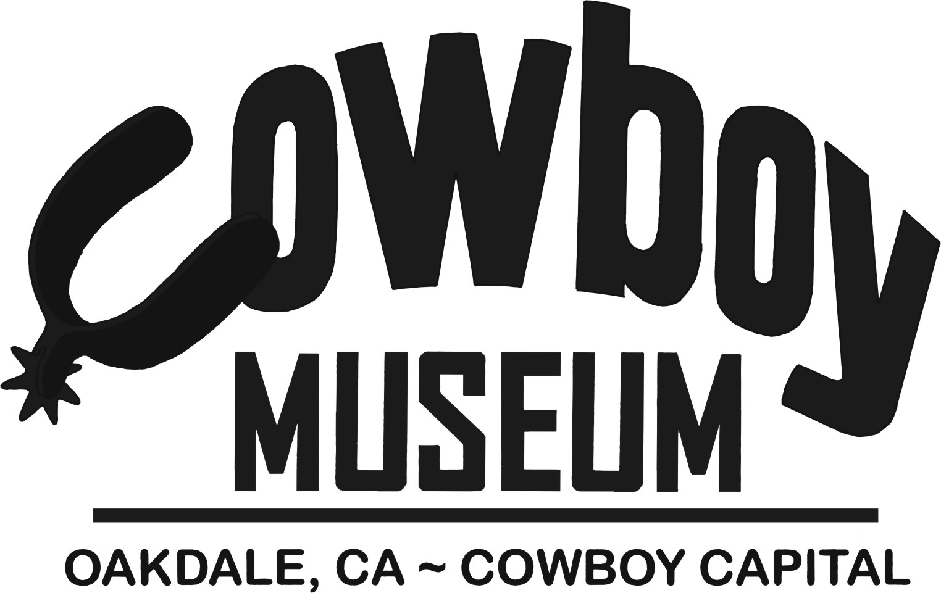
355 East “F” Street Oakdale, CA 95361
(209) 847-5163 or (209) 847-4183 Fax

APPLICATION FOR SCHOLARSHIP

CRITERIA FOR SCHOLARSHIP: The Oakdale Cowboy Museum is presenting scholarships to deserving High School seniors in the Central Valley region. One of these scholarships will go a graduating senior whose family is a member of the Oakdale Cowboy Museum. Scholarships are to be used at a two or four year college or university. The applicant must be actively involved in rodeo, livestock or animal production. This is a merit scholarship and is not based on financial need. Applicants must have an accumulative GPA of 2.5 or higher.

STUDENT APPLICATION: (Please print)

Name:___________________________________________________
First MI Last

Address:_________________________________________________

__________________________________________________________

Telephone:_________________________________________________

Parent Names:______________________________________________

Home Phone:___________________Cell:_________________________

HIGH SCHOOL COURSES OF STUDY (You may check more than one)

Agriculture_________Business____________College Prep__________

GPA___________(As of 1st Semester of Senior Year)

Signature of Counselor_________________________
Oakdale Cowboy Museum
Application for Scholarship
Page 2

LIST CLUBS AND ORGANIZATIONS (offices held if applicable)
________________________________________________________________________________________________________________________________________________________________________________________________________________________________________________________________

LIST COMMUNITY SERVICE, HOBBIES, AND ACTIVIES
OUTSIDE OF SCHOOL
________________________________________________________________________________________________________________________________________________________________________________________________

EMPLOYMENT HISTORY
________________________________________________________________________________________________________________________________________________________________________________________________

WHAT DO YOU FEEL ARE YOUR TWO MAJOR ACHIEVEMENTS IN HIGH SCHOOL?
________________________________________________________________________________________________________________________________________________________________________________________________

DECRIBE YOUR UNDERSTANDING OF THE COWBOY MUSEUM AND ITS GOALS AND/OR EFFORTS IN THE COMMUNITY. DESCRIBE ANY FAMILY INVOLVEMENT WITH THE OAKDALE COWBOY MUSEUM IF APPLICABLE.
________________________________________________________________________________________________________________________________________________________________________________________________

PLEASE LIST YOUR TOP THREE CAREER CHOICES

- _______________________________
- _______________________________
- _______________________________
Oakdale Cowboy Museum
Application for Scholarship
Page 3

The following items must be attached with your application:

- Two letters of recommendation

- An essay (no longer than two-three pages please) entitled “My Western heritage is the Basis of my Future.” Please include how your western heritage has helped shape who you are as a person and how you see yourself involved in competition, production and or care of livestock in the future.

- Official transcript

This application is to be returned to the Oakdale Cowboy Museum at 355 East “F” Street in Oakdale, CA by March 13, 2015.

Scholarship finalists will be asked to participate in an interview with the Oakdale Cowboy Museum Scholarship Committee.

Signature of Student:

__________________________________________

